Addendum 1
DOFAW-KAU-26
Kau Unit 3 Fencing Project, Hawaii Island
This addendum responds to questions asked at the pre-bid conference and makes changes to the IFB.
- While there is a possibility of being able to drive in to the unit, that is contingent upon US National Park Service approval and coordination, which cannot be relied upon. For example, during government shutdowns and other unforeseen events, they are not available to provide access. We recommend that bidders bid the job as a helicopter access job.
- While DOFAW can flag and identify the drop zones (DZ), we also would be open to the contractor flagging and identifying the DZs if they prefer, in case the contractor wants to have more control over where the DZs will be.
- We have included an additional map that indicates helicopter landing zones (LZ). While the “Kau Coffee Mill” LZ is easiest to drive into, DOFAW currently has a handshake deal so that is not certain. The Kapapala Ranch LZ access is the closest to Hilo and is behind a locked gate. DOFAW does have a ROE for the Kamehameha Schools LZ (Paauau/Alii Spring) 1.5 hour from Hilo behind a locked gate as well. The KS access key will need to be issued. Additional LZs can be created (within reason of forest type) in the Forest Reserves to accommodate construction.
  - (map is on page 2 of this document)

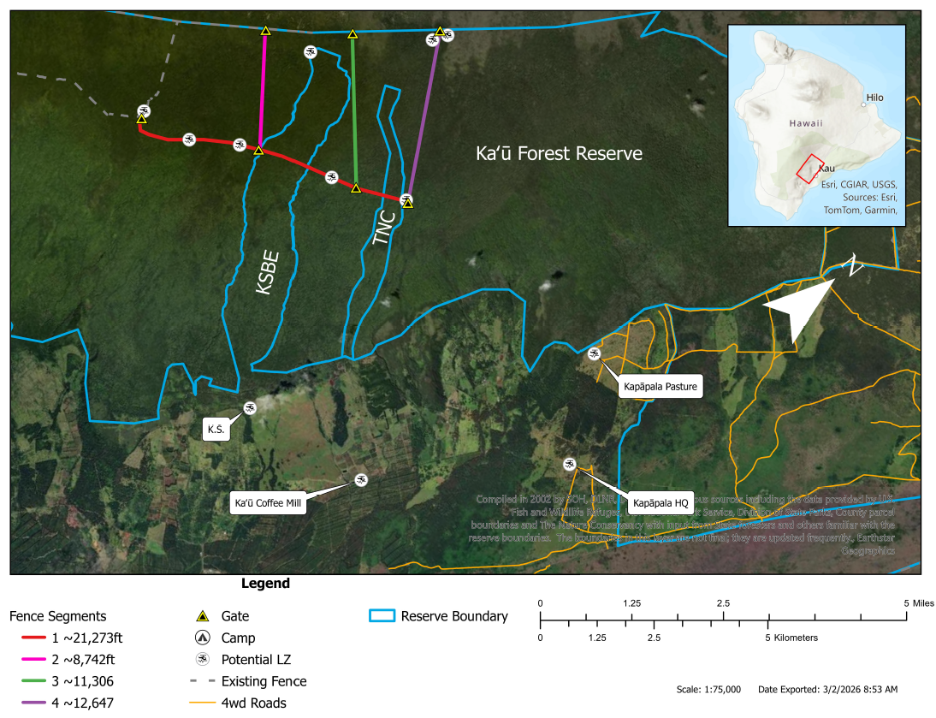
- Why is there so much information in the IFB about helicopter policies?
  - The Right-Of-Entry between DLNR and The Nature Conservancy included the State’s helicopter operating policy, which applies to the safety standards required for DLNR staff to use helicopters.
The following changes have been made:
- Offer form:
  - FROM:
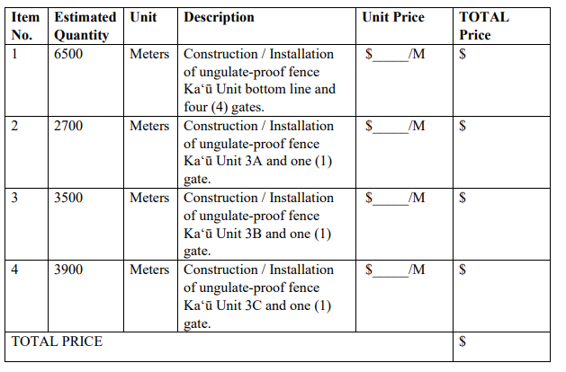
  - TO:
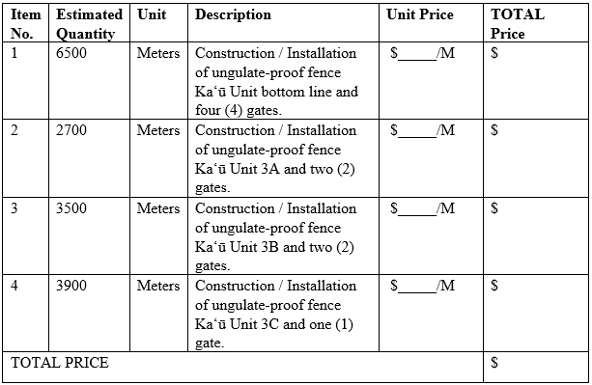
- Gate Design Examples: Delete pages 89 and 90 (last two pages in Exhibit D) with pictures of the platform pedestrian gate. We will not be using this style gate. Instead, the pedestrian gate on page 88 will be used.
- DOFAW Schedule: On page 13, the deadline to submit a bid has been updated from March 31, 2026 to April 7, 2026.

